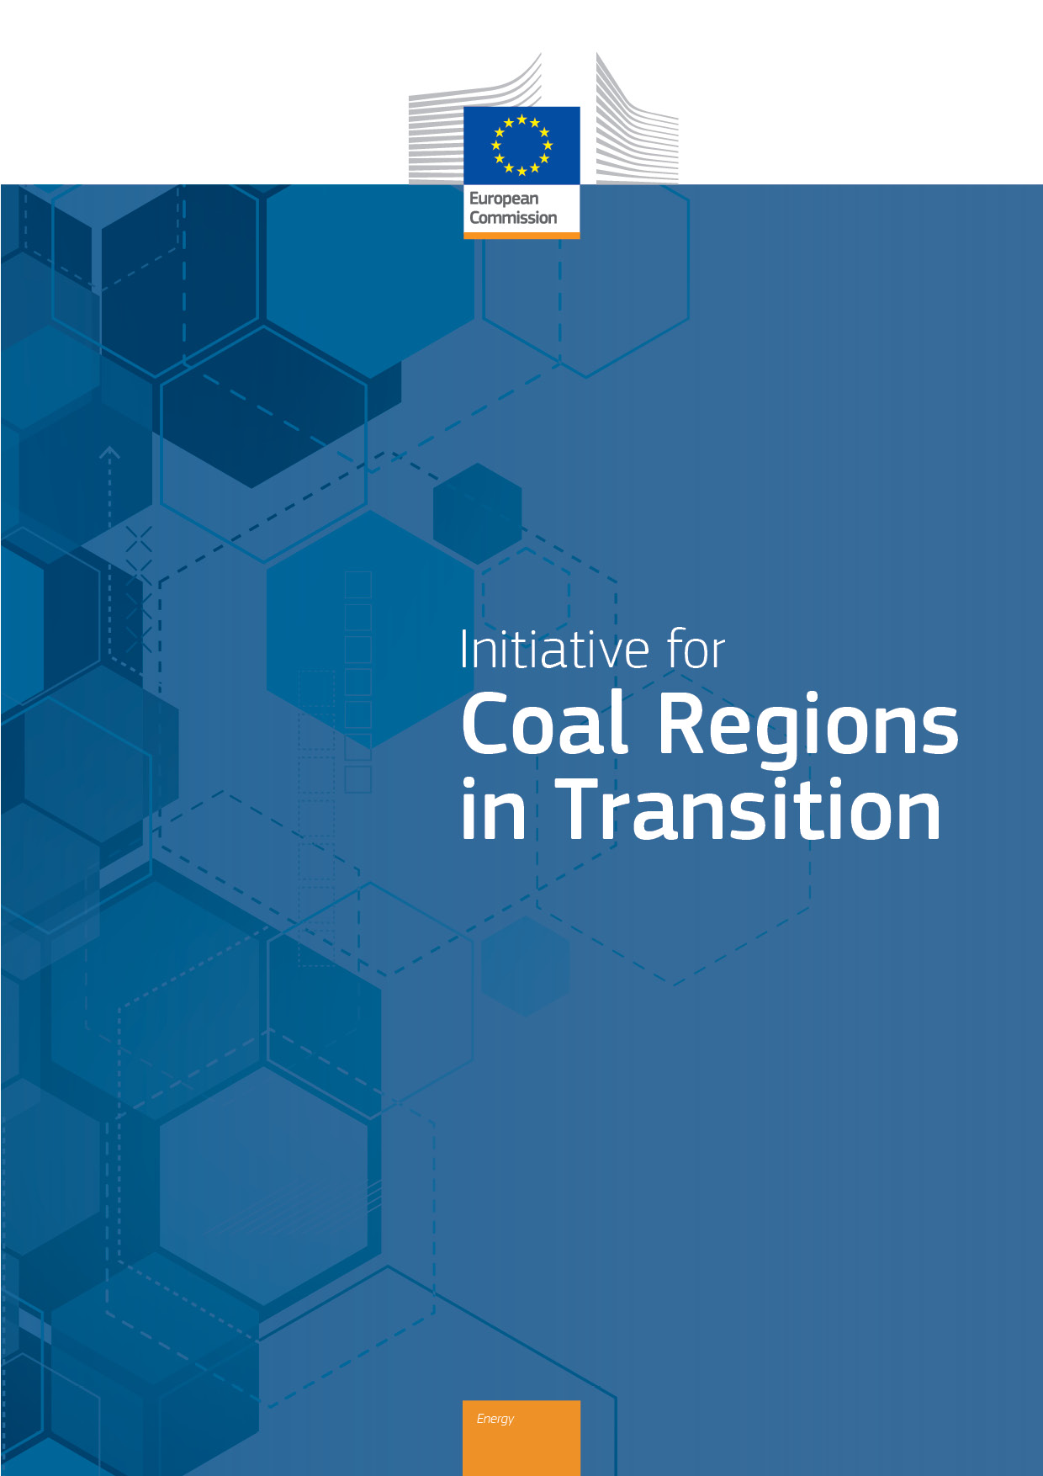

START Service Level Agreement & Workplan

Silesia, Poland

## Secretariat Technical Assistance for Regions in Transition (START)

# Service Level Agreement

*Between*

**Secretariat of the Initiative for EU Coal regions in Transition**

c/o Ecorys

Rue Belliard 12

1040 Brussels, Belgium

Name of representative: Carlo Della Libera

Position: Global Practice Leader, Energy and Sustainability

Tel: +32 (0) 478780599

e-mail: [carlo.dellalibera@ecorys.com](mailto:carlo.dellalibera@ecorys.com)

*and:*

**Marshal Office of the Silesian Voivodeship**   
ul. Ligonia 46, 40-037 Katowice, Poland

Name of representative: Jakub Chełstowski

Position: Marshal of the Silesian Voivodeship

Tel: +48 (32) 20 78 290

e-mail: [marszal@slaskie.pl](https://bip.slaskie.pl/cms/adminPage/edit/mailto:)

Name of the officer authorised to sign the Agreement: Małgorzata Staś

Position: Director of the Department of Development and Transition of the Region, Marshal Office of the Silesian Voivodeship

Tel: +48 (32) 77 99 282

e-mail: [fundusze@slaskie.pl](mailto:fundusze@slaskie.pl)

WHEREAS the Marshal Office of the Silesian Voivodeship,represented by Małgorzata Staś, hereafter ‘the Applicant’, has applied for technical assistance support through the Secretariat Technical Assistance for Regions in Transition (START) facility.

WHEREAS the European Commission, hereafter ‘the Commission’, has confirmed the admissibility of the Applicant’s application to receive support through the START facility.

WHEREAS Ecorys, represented by Carlo Della Libera, is the leader of the Consortium[1], hereafter ‘the Service Provider’, appointed by the Commission to provide services for operating the Secretariat of the Platform for Coal Regions in Transition and, in this capacity, for managing the delivery of START support services.

WHEREAS the Service Provider is desirous and capable to provide services within the scope of the technical assistance support requested by the Applicant.

WHEREAS the Applicant, the Service Provider and the Commission, hereafter collectively ‘the Parties’, share a common ambition to achieve economic diversification and clean energy technological transition in coal mining regions that is fair and respectful of local communities and citizens.

The following has been agreed:

1. **Context of the Agreement**

The Initiative for EU Coal Regions in Transition is designed to assist regions in facilitating a Just Transition in communities affected by planned and ongoing phase-out of coal, peat and oil shale extraction and their application for power generation.

Technical assistance support provided through the START facility is intended to help build capacity, improve knowledge, and offer advice to public administrations and other relevant stakeholders to formulate regional transition strategies, and to plan for, govern and implement a Just Transition in coal, peat and oil shale regions.

Technical assistance support provided through the START facility is not intended as an alternative to existing support structures. Rather, it should complement existing efforts of the Member State, the Region(s) and the European Commission and other organisations that support transition in coal and other carbon intensive regions and communities. It is not intended as a mechanism for funding either the development of transition strategies or the implementation of transition projects.

1. **Purpose of the Agreement**

The purpose of this Service Level Agreement (SLA) is to outline the main elements and necessary commitments to provide technical assistance support services to the Applicant by the Service Provider.

The goal of this Service Level Agreement (SLA) is to facilitate mutual understanding and agreement between the Service Provider and the Applicant concerning the content and scope of technical assistance support provision.

The objectives of this agreement are to:

* provide a clear reference to the respective roles and responsibilities of the Service Provider and the Applicant for the provision and receipt of technical assistance support services;
* provide a clear and concise description of the technical assistance support services to be delivered by the Service Provider;
* provide an outline description of the expected planning and timeframe for the provision and receipt of technical assistance support services;
* assist in matching perceptions of expected services provision with actual services provision.

1. **Duration of the Agreement**

This SLA enters into force on the date of last signature by all the Parties.

This SLA will terminate without further notice upon completion of delivery of the technical assistance support services, as described herein, by the Service Provider.

Notwithstanding prior termination, this SLA will automatically expire on 1 March 2024, together with any and all residual or outstanding obligations of the Parties under this Agreement.

1. **Undertaking**

By signing this SLA, the Applicant confirms their request for and willingness to receive support services from the Secretariat Technical Assistance for Regions in Transition (START) facility.

Further, by signing this SLA, the Applicant is agreeing to demonstrate their capacity and commitment to the effective implementation and utilisation of START support services. This will be done through allocating adequate resources to actively manage, realise, apply, and follow-up on the provided support activities.

It is understood that the Applicant’s provision of adequate resources is not intended to imply the imposition of additional costs on the Applicant nor to imply a commitment by the Applicant to provide additional financial means.

By signing this SLA, the Service Provider commits to deliver the support activities and outputs outlined herein in a professional manner, respecting the situation and needs of the Applicant and any other identified recipients of the technical assistance support services.

1. **START Team**

The Service Provider will make available a START Team consisting of the following members:

* **START service coordinator**: this person will manage and oversee the provision of technical support services provided to the Applicant.
* **Senior and junior consultants**: these will be persons with relevant economic, business, technical or other expertise who will be assigned to the START Team based on the needs and proposed activities of the support services to be provided.

The START Team assigned under this SLA is composed of:

|  |  |  |
| --- | --- | --- |
| Name | Position | Role / expertise |
| Helen Franzen | Service coordinator | Coordinator, Strategic Communications & Campaigns, ICLEI Europe |
| Adrienne Kotler | Expert | Officer, Strategic Communications & Campaigns, ICLEI Europe |
| Aleksandra Jasinka | Expert | Senior Consultant, Sustainability Team, Ecorys PL |
| Aleksander Szpor | Expert | Lead Consultant, Ecorys PL |
| Anna Borowczak | Expert | Senior Consultant, Sustainability Team, Ecorys PL |

1. **START Resources**

The Service Provider will deliver a support package corresponding to a total of 75 person-days of senior technical support. This total includes time of the START Team members incurred for travelling, preparation, delivery, and follow-up of the provided support services.

*An expected indicative breakdown of the distribution of person-days is detailed in the next section.*

1. **START Activities**

The support package will consist of the activities and outputs outlined below.

*The support package is further described in the Workplan annexed to this document.*

*The timetable is indicative and may be subject to revision.*

|  |  |  |  |  |  |
| --- | --- | --- | --- | --- | --- |
| **Outline of START activities** | | |  | |  |
|  |  | Indicative input  (person-days) | | Monitoring indicators | |
|  | Activity name | START Team | Applicant | Completion date | Outputs |
|  | **Assessment of needs and field visit** | **5** | **--** | 6.4.2023 | Summary report |
|  | **Task 1: Survey creation** | **15** | **50** | 29.9.2023 | Survey; survey analysis report and summary |
| 1.1 | Survey preparation and consultation with Marshal’s Office | 12 | 15 | 2.6.2023 |  |
| 1.2 | Survey dissemination | -- | 15 | 8.9.2023 |  |
| 1.3 | Analysis and presentation of survey results | 3 | 20 | 29.9.2023 |  |
|  | **Task 2: Website review** | **20** | **20** | 20.10.2023 | Mock-ups depicting options for website re-design |
| 2.1 | Website review | 10 | 5 | 8.9.2023 |  |
| 2.2 | Feedback from regional stakeholders | -- | 10 | 6.10.2023 |  |
| 2.3 | New website proposals | 10 | 5 | 20.10.2023 |  |
|  | **Task 3: Handbook for Transition Communication** | **30** | **30** | 1.12.2023 | Handbook for Transition Communication |
| 3.1 | Prepare framework for communication strategy development | 10 | 10 | 6.10.2023 |  |
| 3.2 | Tips for effective transition communication | 5 | 5 | 27.10.2023 |  |
| 3.3 | Identify and analyse best practices | 15 | 15 | 16.6.2023 |  |
|  | **Finalisation (Reporting)** | **5** | **--** | 15.12.2023 | Final report |
|  | Preparation and submission of START Summary Report(s) | 5 | -- | 15.12.2023 |  |
|  | **TOTAL** | **75** |  |  |  |

1. **Signatures**

Conditions agreed

*For the Applicant*

Name: Małgorzata Staś

Position: Director of the Department of Development and Transition of the Region, Marshal Office of the Silesian Voivodeship

Place: Katowice, Poland

Date:

*For the Service Provider*

Name: Carlo Della Libera

Position: Global Practice Leader, Energy and Sustainability

Place: Brussels, Belgium

Date: 23.05.2023

## Secretariat Technical Assistance for Regions in Transition (START)

# Workplan: Silesia, Poland

#### Title of the request: Support improving transition communication

#### Lead applicant organisation: Marshal Office of the Silesia Voivodeship

## Introduction

This Workplan has been developed taking due consideration of the application for START support made by the Marshal Office of the Silesia Voivodeship, findings and discussions from the initial ‘fact-finding’ visit of START representatives (4-6 April 2023), and follow-up dialogue with recipient.

Additional information on the context and situation of energy transition is offered in the associated regional fact-sheet.

## As set out in the application for START support, the recipient seeks technical assistance for (paraphrased):

* Creating a sustainable model for transition communication that accounts for mutual learning (i.e., for flows of communication both from the Marshal Office to stakeholders, and vice versa)
* Increasing awareness and understanding of regional transition among key stakeholders and the general regional public
* Ensuring that transition communication maintains, complements and leverages the strong involvement of stakeholders in Silesia’s transition process

## Tasks, activities and deliverables

### Task 1: Survey creation

**Aims:** To support the Marshal’s Office in creating, disseminating, and analysing the results from a survey, sent to stakeholders of the transition process in the region, including the 61 organisations that make up the Regional Council, which seeks to better understand what communications tools and information they need to better communicate about Silesia’s transition. The results of the survey will help to see what questions need answering, what groups needs to be particularly targeted, and what resources the Marshal’s Office may be able to provide. The survey will not be written with individual inhabitants in mind, but will be shared publicly on the Marshal’s Office website for any other organisation or stakeholder (i.e. those not part of the Regional Council) to access.

**Methods:** Initial review of a draft survey put together by the Marshal’s Office, keeping in mind both useability (is the survey succinct, clear, going to provide the necessary information) and rigour (are the questions phrased without being leading). This step will include rounds of consultation among the Marshal’s Office and the START team. The Marshal’s Office will then disseminate the survey to its Regional Council and on its channels. Finally, the START and Marshal’s Office teams will together review the responses and prepare a basic presentation of survey findings.

**Indicative timeline:** April-September 2023

Activity 1.1: Survey preparation and consultation with Marshal’s Office

Activity 1.2: Survey dissemination

Activity 1.3: Analysis and presentation of survey results

|  |  |  |
| --- | --- | --- |
| **Task 1 Deliverables** | | |
|  | Deliverable name | Deliverable description |
| D1.1 | Communication needs assessment survey | A survey that is disseminated to key stakeholders and generally via the Marshal Office website. |
| D1.2 | Dissemination plan | A plan outlining how the survey will be disseminated, and how dissemination across outlets is GDPR-compliant. |
| D1.3 | Analysis of survey results | Document outlining results and findings gleaned from the survey, presented both question-by-question, and as overarching results and main takeaways. |
| D1.4 | Summary of survey results | Powerpoint presentation summarising key findings from the survey, drawing on D1.3. |

### Task 2: Website review

**Aims:** The region has a dedicated website for the Just Transition of Silesia ([transformacja.slaskie.pl](https://transformacja.slaskie.pl/)), which currently acts as a ‘notice board’ where the Marshal’s Office can share basic updates. At the end of 2023, the website will go through an extensive (and well-resourced) re-vamping process. Ahead of this re-vamp, START will review the website to provide advice and possible paths that the region can pursue to make the website more useable, suitable for more dynamic interaction and communication, and ensure that it better meets the needs of stakeholders, as outlined in the survey (Task 1).

**Methods:** As a first step, the START team will host a meeting with colleagues from the Marshal’s Office (including the communications team) to distil the region’s main goals for their new website, including what deficiencies they face with their current website. Next, the START team will go through a thorough website review, identifying areas for improvement webpage-by-webpage, and for the overarching website structure. The review will cover items such as: user journey, interactivity, readability and accessibility, clarity of visuals, and consistency in brand. Critiques and suggestions for improvement will be presented to the Marshal’s Office, who will then lead a process of consulting with other stakeholders (including website users) and departments. Finally, based on the results of this consultation process, START will propose a few options – accompanied by mock-ups – for how the website could be designed.

**Indicative timeline:** July-November 2023

Activity 2.1: Website review

Activity 2.2: Feedback from regional stakeholders

Activity 2.3: New website proposals

|  |  |  |
| --- | --- | --- |
| **Task 2 Deliverables** | | |
|  | Deliverable name | Deliverable description |
| D2.1 | Website mock-ups | PDF documents that visually lay out a series of suggestions for improving the Just Transition of Silesia website |

### Task 3: Handbook for Transition Communication

**Aims:** To set the Marshal’s Office and its partners up with the guidance needed to build successful and tailored communications strategies to accompany TJTP implementation. The handbook will articulate overarching guiding principles and objectives for transition communication in Silesia; compile good (communications) practices from other regions; propose a framework/template for creating communications strategies; and provide transition communication tips.

**Methods:** The START team and Marshal’s Office will meet to build upon the ideas already shared during the fact-finding visit for guiding communication objectives and principles. Next, desk research and interviews with communications experts from other regions (some of whom have already been identified) will be used to gather a collection of good communication practices. Finally, the START team will review, adapt and tailor existing frameworks and tips for communication – including those created by ICLEI. All of this information will be compiled (divided into sub-sections) and published as a publicly-accessible Handbook for Transition Communication. In addition, the START team will work with the Silesian Voivodeship to ensure that the Handbook is delivered in formats that make it easy for them to present to key stakeholders in trainings and workshops, and then to adapt based on stakeholders’ feedback and experiences using the Handbook.

**Indicative timeline:** June-December 2023

Activity 3.1: Prepare framework for communication strategy development

Activity 3.2: Tips for effective transition communication

Activity 3.3: Identify and analyse best practices

|  |  |  |
| --- | --- | --- |
| **Task 3 Deliverables** | | |
|  | Deliverable name | Deliverable description |
| D3.1 | Handbook for Transition Communication | Handbook consisting an *approach section* with guiding principles, objectives and context; a *framework* for setting up effect communications strategies; *tips* for effective communication; and less*ons from communication best practices* from other regions and organisations. |

### Task 4: Finalisation

Finalisation and collation of all delivered technical assistance outputs. Drafting recommendations for follow-up activities to the delivered START assistance. Collection of feedback from START recipients on the performance and outcomes of START assistance.

## Organisation of technical assistance

### START Team and Management

The START Team assigned under this SLA is composed of:

|  |  |  |
| --- | --- | --- |
| Name | Position | Role / expertise |
| Helen Franzen | Service coordinator | Coordinator, Strategic Communications & Campaigns, ICLEI Europe |
| Adrienne Kotler | Expert | Officer, Strategic Communications & Campaigns, ICLEI Europe |
| Aleksandra Jasinka | Expert | Senior Consultant, Sustainability Team, Ecorys PL |
| Aleksander Szpor | Expert | Lead Consultant, Ecorys PL |
| Anna Borowczak | Expert | Senior Consultant, Sustainability Team, Ecorys PL |

### Allocation of Resources

The proposed (indicative) allocation of resources for the assignment is as follows:

|  |  |  |  |
| --- | --- | --- | --- |
| **Indicative allocation of resources (person-days)** | | | |
|  | Activity name | START Team | Applicant |
|  | **Assessment of needs and field visit** | **5** | -- |
|  | **Task 1: Survey creation** | **15** | **50** |
| 1.1 | Survey preparation & consultation with Marshal’s Office | 12 | 15 |
| 1.2 | Survey dissemination | -- | 15 |
| 1.3 | Analysis & presentation of survey results | 3 | 20 |
|  | **Task 2: Website review** | **20** | **20** |
| 2.1 | Website review | 10 | 5 |
| 2.2 | Feedback from regional stakeholders | -- | 10 |
| 2.3 | New website proposals | 10 | 5 |
|  | **Task 3: Handbook for Transition Communication** | **30** | **30** |
| 3.1 | Prepare framework for communication strategy development | 10 | 10 |
| 3.2 | Tips for effective transition communication | 5 | 5 |
| 3.3 | Identify and analyse best practices | 15 | 15 |
|  | **Finalisation (Reporting)** | **5** | **--** |
|  | Preparation and submission of START Summary Report(s) | 5 | -- |
|  | **TOTAL** | **75** | **100** |

***Note:*** *The allocation of Applicant resources relates to inputs for coordination, management and direct contributions to jointly implemented aspects of START activities. It does not cover inputs relating to the adoption, application/utilisation and dissemination of outputs delivered through START activities.*

### Timetable of Activities

The proposed (indicative) timetable for the assignment is as follows; note that a Gantt chart is also available, upon request:

|  |  |  |  |
| --- | --- | --- | --- |
| **Indicative timetable of START activities** | | | |
|  | Activity name | Anticipated start date | Anticipated completion date |
|  | **Task 1: Survey creation** | 15.5.2023 | 29.9.2023 |
| 1.1 | Survey preparation & consultation with Marshal’s Office | 15.5.2023 | 2.6.2023 |
| 1.2 | Survey dissemination | 5.6.2023 | 8.9.2023 |
| 1.3 | Analysis & presentation of survey results | 11.9.2023 | 29.9.2023 |
|  | **Task 2: Website review** | 31.7.2023 | 20.10.2023 |
| 2.1 | Website review | 31.7.2023 | 8.9.2023 |
| 2.2 | Feedback from regional stakeholders | 11.9.2023 | 6.10.2023 |
| 2.3 | New website proposals | 9.10.2023 | 20.10.2023 |
|  | **Task 3: Handbook for Transition Communication** | 15.5.2023 | 1.12.2023 |
| 3.1 | Prepare framework for communication strategy development | 10.7.2023 | 6.10.2023 |
| 3.2 | Tips for effective transition communication | 23.10.2023 | 27.10.2023 |
| 3.3 | Identify and analyse best practices | 15.5.2023 | 16.6.2023 |

***Note:*** *The timetable is indicative and may be subject to revision and further agreement. The timetable may be changed depending on the availability and operational priorities of the of the START team considering also overall commitments under the START support facility and unforeseen circumstances, such as restrictions caused by COVID-19.*



1. The Consortium is formed by the following partners: Ecorys, Wuppertal Institute, ICLEI, and Climate Strategies.